What is a Class?
A class in C# is a template or blueprint for creating objects. It defines the properties, fields, and methods that an object created from that class will have. Classes encapsulate both data (attributes) and behavior (methods) within a single unit, supporting the core principles of Object-Oriented Programming (OOP).

Key Features of a Class:
- Properties/Fields: Variables that store data about the class (e.g., Color, Model in a Car class).
- Methods: Functions that define behaviors or actions the class can perform.
- Constructors: Special methods that are called when an object is instantiated, used to initialize properties.

Example of a Class (Car):
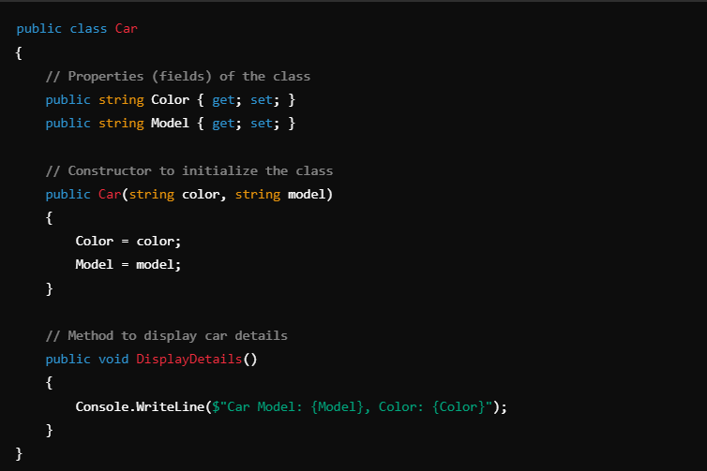
In this example:
- Car is the class.
- Color and Model are properties.
- DisplayDetails() is a method that prints the details of the car.

2. Helper Classes
A helper class is a class designed to provide utility functions that help with common tasks or operations across different parts of a program. These are typically static classes and don’t represent an entity in the problem domain but are used to aid functionality in other classes.

3. DataType Classes
DataType classes are often used to represent or encapsulate data types. In C#, basic data types like int and double are not classes but are represented as structs. However, you can create custom classes to represent more complex data types, or use existing data type classes like Int32 (for integers) or Double (for floating-point numbers).
For instance, C# has built-in wrapper types for primitive data types, but you can also create custom data type classes.

Example of a DataType Class (Car as a DataType Class):
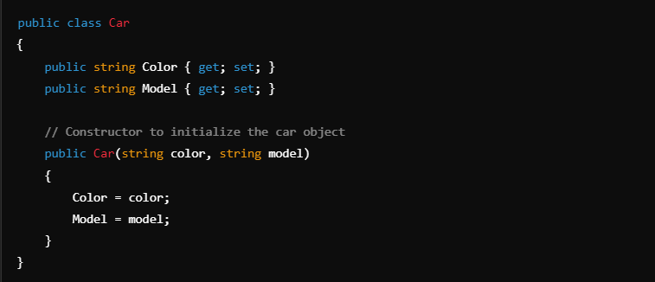
In this example, the Car class represents a complex data type that combines two attributes: Color and Model. While int and double are simple data types, Car is a custom data type class designed to hold more complex information.

4. When Will the Compiler Create a Default Constructor?
The default constructor is a constructor that takes no parameters. It is created by the compiler when no constructors are explicitly defined in the class. The default constructor initializes all fields to their default values.

Default Constructor Behavior:
- If no constructors are defined, the compiler provides a default constructor that sets the fields to default values (0, null, false).
- If any constructor is defined (even a parameterized constructor), the default constructor is not provided unless you define it explicitly.

Example:
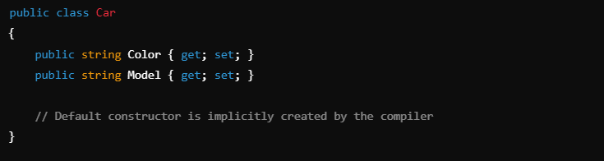
Here, if no constructor is explicitly defined, the compiler will automatically create a default constructor. However, if you define a parameterized constructor like this:
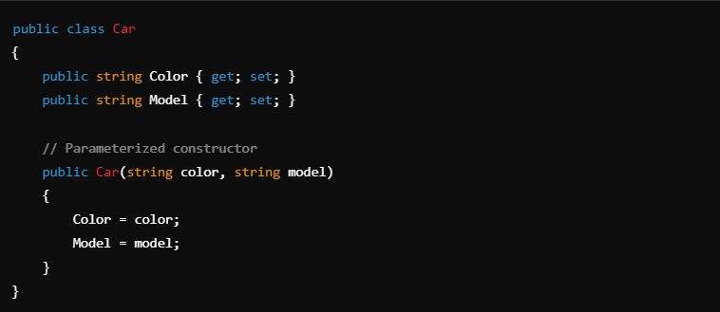
The default constructor will not be automatically generated unless you define it yourself.

5. Constructor Chaining
Constructor chaining refers to the practice of calling one constructor from another within the same class or between base and derived classes. In C#, constructor chaining can be done using the this keyword (for calling another constructor in the same class) or the base keyword (for calling a base class constructor).

Constructor Chaining within the Same Class:
Using the this keyword, you can call one constructor from another in the same class. This is helpful when you want to use the same logic in multiple constructors but don’t want to duplicate code.

Example of Constructor Chaining:
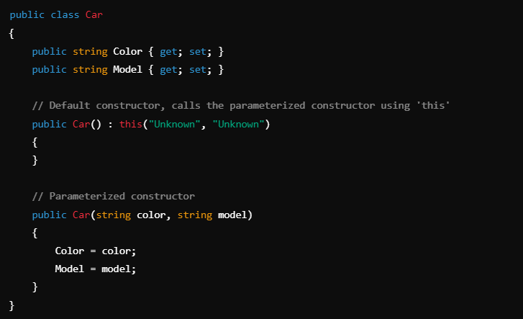
In this example:
- The default constructor Car() calls the parameterized constructor Car(string color, string model) using this("Unknown", "Unknown").

Constructor Chaining with Inheritance:
When dealing with inheritance, the base keyword is used to call a constructor of the base class from a derived class.
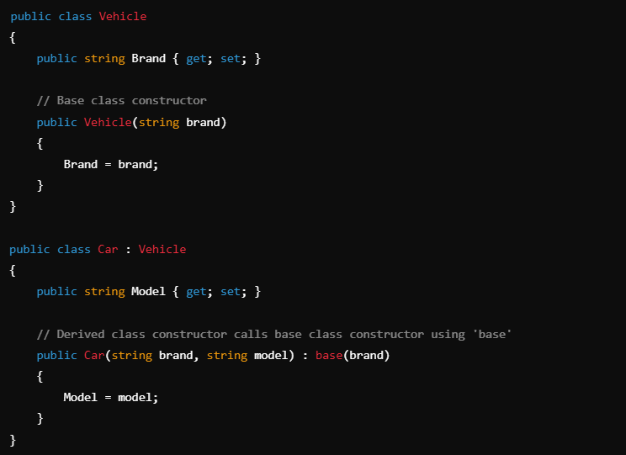
In this example:
- The Car class calls the Vehicle class constructor using base(brand) to initialize the Brand property in the base class before setting the Model property in the derived class.

Struct vs. Class
- Purpose:
  - Struct: Used exclusively for data representation.
  - Class: Can represent data and define complex behaviors.
- Memory Allocation:
  - Struct: Allocated on the stack.
  - Class: Allocated on the heap.
- Type:
  - Struct: Always a value type.
  - Class: Always a reference type.

Stack Vs Heap
- What is:
  - Stack: It’s an array of memory, LIFO (Last In First Out) Data Structure
  - Heap: It’s a pool of objects, which is used to store objects in random locations in that pool
, Data in heap can be stored and removed in any order
- Size:
  - Stack: Fixed Size
  - Dynamic: Shrinks, Expands During Run-Time
- Allocation Speed:
  - Stack: Faster, as it always will be allocated on top of the stack when declaring the variable
  - Heap: Slower, as the compiler will look for a place in the heap that can take the size of that instance if he doesn’t find any space for this instance it will expand the heap
- Memory Management:
  - Stack: Cleared Auto-Cleared, not managed by GC
  - Heap: Most Things in heap is managed by GC ,but there is objects that’s the developer have to manage it by himself
- Accessibility:
  - Stack: on the stack can only be accessed by teehee function that created it and any functions called by that function
  - Heap: can be accessed by any part of the program

Inheritance

What is inheritance?
One of the OOP Pillers That allows a class to inherit members of another class Allowing to Code Ruse
There is Types of inheritance C# Supports
- Single Inheritance
- Multilevel Inheritance
- Hierarchical Inheritance Multiple Classes Inherits the Same Base
NOTE: C# Does not support multiple class inheritance directly

Problems Before Inheritance?
- Code duplication
- Difficulty in Achieving Polymorphism

Inheritance Related Access Modifiers
- Private Protected
- Protected
- Internal Protected
Access Modifier | No Inheritance (Direct Access) | Inheritance – Same Assembly | Inheritance – Different Assembly
protected | ❌ Not accessible from outside the class | ✅ Accessible in derived class | ✅ Accessible in derived class
private protected | ❌ Not accessible from outside the class | ✅ Accessible only in derived class within same assembly | ❌ Not accessible in derived class in another assembly
protected internal | ❌ Not accessible from outside the class | ✅ Accessible in derived class OR same assembly non-derived class | ✅ Accessible in derived class OR if in same assembly (non-derived)

After Inheritance
Private Protected Private
Protected Private
Internal Protected Internal

Relationships Between Classes

Inheritance
Inheritance is when a new class (called a child) takes on the features and behaviors of an existing class (called the parent). It’s like saying "a Cat is an Animal".
- C# allows single inheritance, so a class can only inherit from one other class.
- It helps you avoid repeating code and lets you build a clear class hierarchy.

Association

Composition
A strong relationship — one class can’t work without the other.
- Think: A Car can’t run without an Engine.
- It’s a "has-a" relationship, and the parts are essential

Aggregation
A looser relationship — one class can exist without the other.
- Think: A Team has Players, but players can exist even without a team.
- Still a "has-a" relationship, just not as tight.

